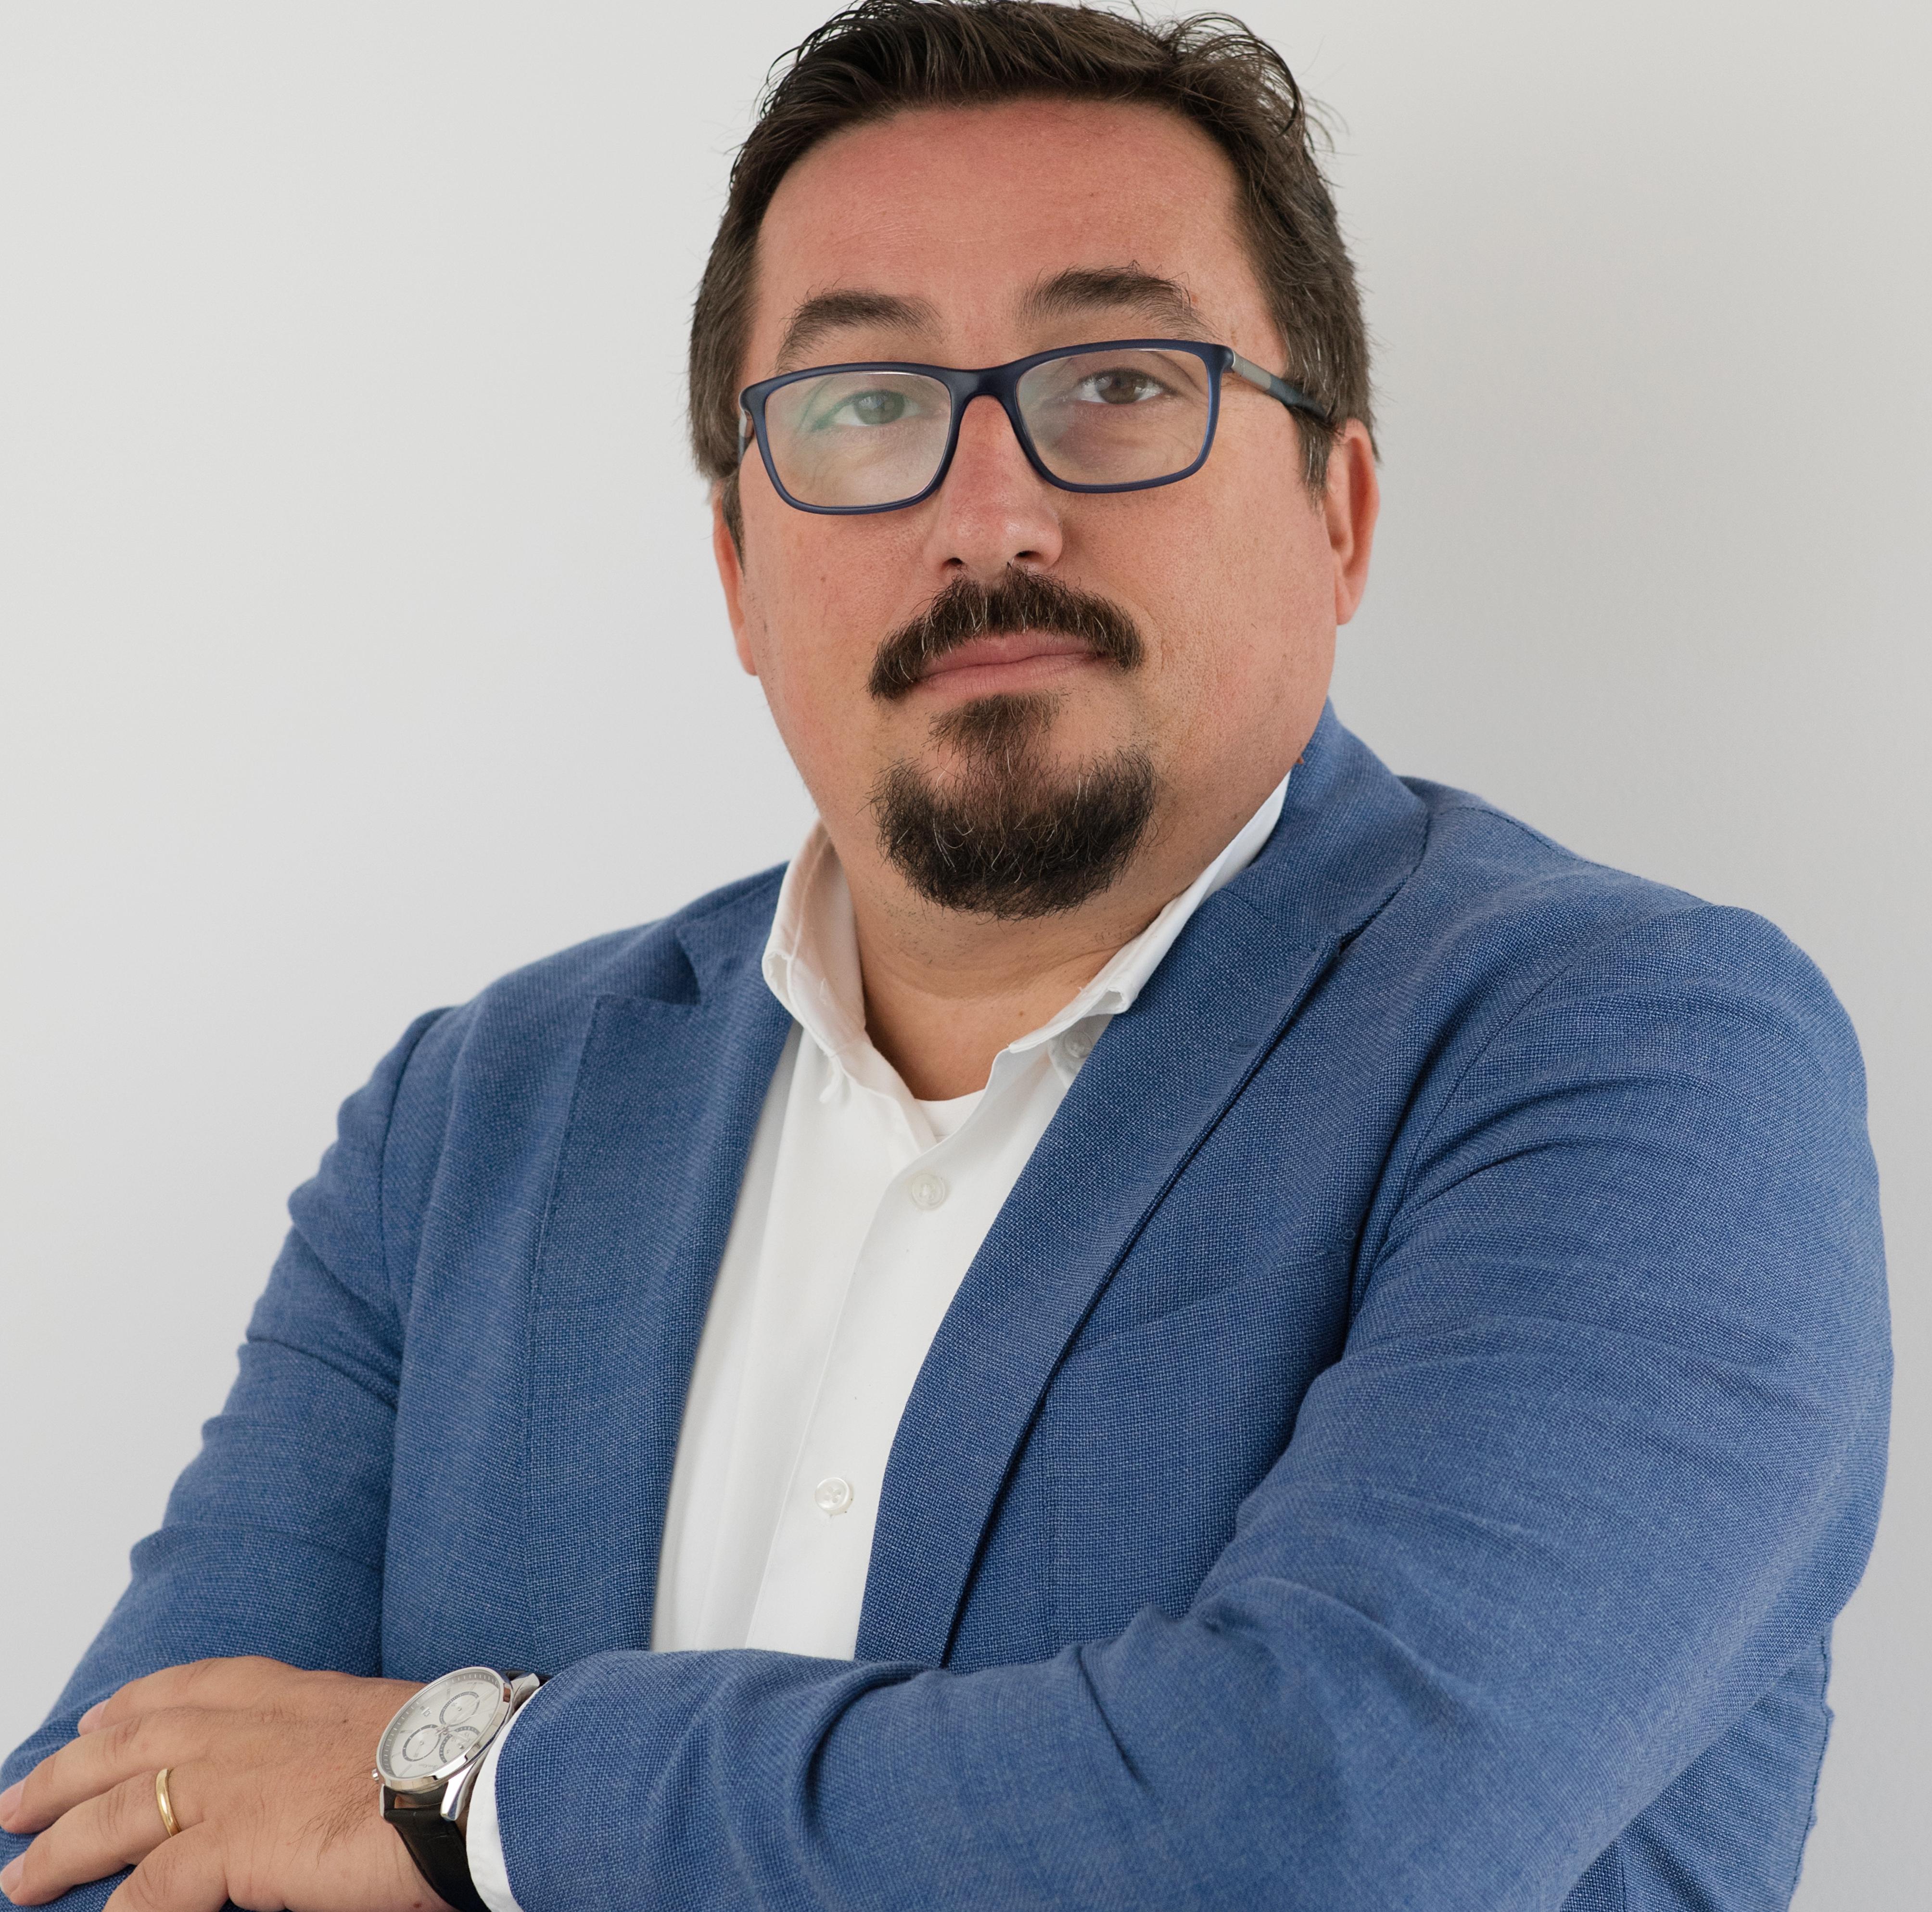 | Kledi Kodra, FCCA, AL  Managing Partner  T: + 355 44 525 880  M +355692081370  E kledi.kodra@al.gt.com

Description

Kledi has more than 21 years of experience with International Accountancy Firms. During this period, Kledi has been responsible for providing a wide range of services provided to both international and local clients including audit, due diligence, accounting consulting, financial control and general management, mainly in banking, insurance, as well as oil and gas, telecommunication, public utility and consumer products industries. Kledi is the head of the Regulatory Committee of the American Chamber of Commerce in Albania. Kledi works closely with the National Standards Setter and is an approved translator of IFRS in Albanian language by the International Accounting Standards Board.

Kledi is a Doctor of Economic Science and serves as a lector of Financial Accounting, Taxation and Audit and Assurance at University of New York in Tirana and of Forensic Accounting at the Faculty of Economy, University of Tirana.

Education
- Harvard Business School – Executive Education – Senior Leadership Programe for Grant Thornton
- Association of Chartered Certified Accountants, London, UK – Full Membership
- Doctor of Economic Science – Agricultural University of Tirana
- Faculty of Commerce and Business Administration, Helwan University, Cairo, Egypt - Bachelor of Commerce and Business Administration - Major of Economics

Employment Record
- Grant Thornton, Albania
- PricewaterhouseCoopers, Albania
- Deloitte, Kosovo
- Deloitte, Albania

Countries of Experience
- Albania
- Kosovo
- Russia
- India

Expertise
- IFRS, ISA, Audit, Due Diligence / Valuations / Project Finance / Mergers & Acquisitions / Transaction Advisory

Membership and Qualifications
- Association of Chartered Certified Accountants, UK – ACCA
- Chartered Authorised Auditor – IEKA – Albania
- Certified Internal Auditor, US - CIA

